Lean operations

The ideal process
- The ideal process has synchronisation of all flows (production on demand, defect free) and operates at the lowest possible cost
- Waste is the gap between ideal and actual values
- We want to synchronise at lowest cost, and set up a system to continually reduce waste

Improvement as process
- The ideal operation is perfectly synchronised with demands, at the lowest cost.
- The actual operation will experience deviation from the ideal in terms of waste variability and inflexibility, which provides opportunity for improvements.
- We want to increase the visibility of these deviations through judoka, Andon pulls, visual management, and exploratory stress.
- We then reduce these deviations using root cause analysis, waste reduction, and variability reduction [six Sigma, TQM]
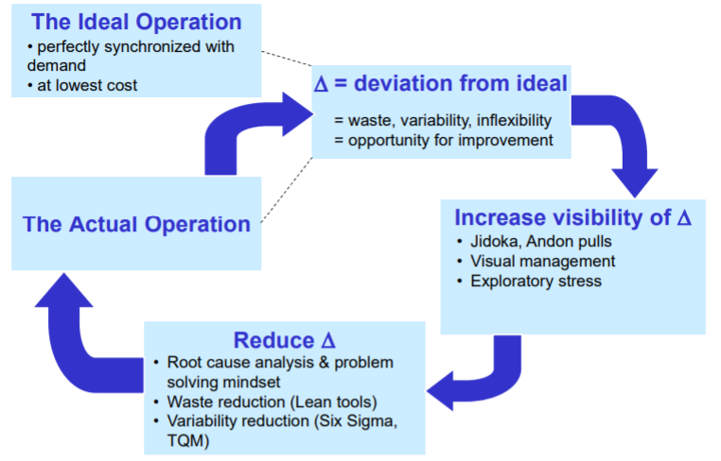

Types of waste
- Inventory – excess products and materials not being processed
- Talents – underutilising people’s talent and knowledge
- Waiting – wasted time waiting for the next step in a process
- Motion – unnecessary movements by people e.g., walking along the line
- Defects – efforts caused by rework, scrap, and incorrect information
- Transportation – unnecessary movements of products and materials
- Overprocessing – more work or higher quality than is required by the customer
- Overproduction – producing more than needed or before it is needed
  - Worst type of waste as the other 6 are its by-products

5 lean principles
- Specify value. Value can only be defined by the ultimate consumer
- Map the value stream
  - Value stream is all actions required to bring products from raw materials through to customers, and which actions add value
- Make value flow. Make products flow without interruption and delays
  - Stoppages collect costs, errors and waste
- Let your customer ‘pull’ what they need, when they need it, making only as required
- Pursue perfection not competitors – achieved by Kaizen and kaikaku

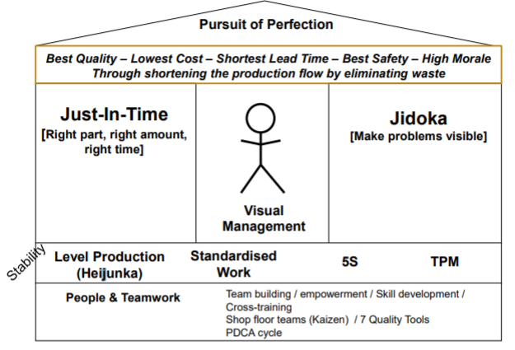
“House of lean”

Jidoka principle
- Increase the visibility of problems in our processes. A key way to do so is by reducing inventory levels.
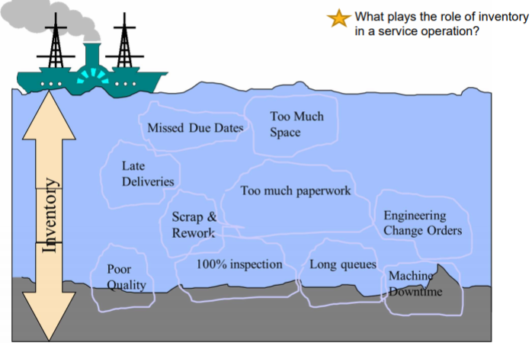
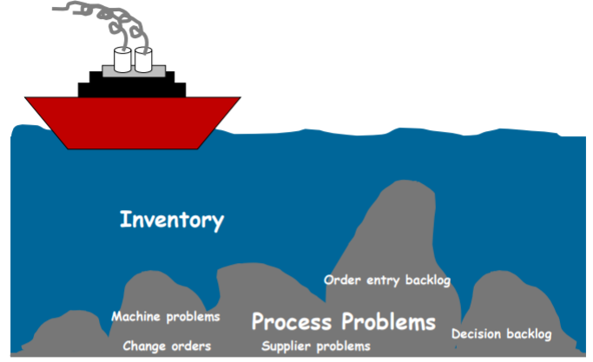
- See the rock-boat analogy:

TPS Elements – Taiichi Ohno
- All processes are driven to be in control and capable.
  - Achieved through standardised work practices, visual management to highlight deviations and then mistake proof processes
- Problems are natural, and opportunities to learn
  - Every problem has a root cause and countermeasures
- Every activity should add value
  - Eliminate muda through Kaizen and Kaikaku
- Make what customers want just in time, using smooth production “pulse”
- Select and invest in people
  - Develop lean leaders who engage and develop problem solving
  - Empowerment, multi-skilling and teamwork

Lean culture
- Lean is a philosophy whereas six sigma is a toolbox to address local problems
  - Lean is not just a waste reduction toolkit, it is a tightly linked process in which problems cannot hide

Recap
- Strives for the ideal by eliminating waste (muda, muri and mura)
- Synchronisation tools include:
  - Once piece flow
  - Cellular layouts
  - Pull production systems (JIT and Kanban)
  - Quality at source
- System of continuous improvement
  - Reduce variability (stability, Six sigma and standardisation)
  - Increase waste visibility through Andon, Jidoka and Poka-Yokes
  - Targeted improvements – root cause analysis using the 5 whys and fishbone diagrams
    - Understand the “real” causes of quality issues
External and internal deadlines
Strategy is matching internal capabilities like operations with external factors
Lean is predominant way of understanding how lean processes work in operations

Further reading

Beyond Toyota summary
https://maaw.info/ArticleSummaries/ArtSumWomackJones96.htm
Five steps to successfully combining lean techniques into a coherent system
- Define value precisely from the perspective of the end customer, in terms of specific capabilities offered at a specific price and time.
  - Conflicting goals – workers may be seeking career progression, departments may seek to use all of their resources, leading to muda
  - Defining value lets us differentiate between value and muda
- Identify the entire value stream for each product and eliminate waste.
  - Value stream is all of the actions required to bring a product through three critical activities: product definition, information management and physical transformation.
  - Typically exposes staggering amounts of muda through backtracking and scrap as the product proceeds through the chain.
- Create good flow between the remaining value-creating steps. The most difficult step in creating a lean system.
  - Batch and queue mentality makes it hard to create a production line with flows consistent with lean thinking concepts of no waiting, downtime or scrap.
- Design and provide what the customer wants only when it is wanted.
  - This requires flexibility, to allow modifications and customisable products to be made on the same production line.
- Pursue perfection – barriers will become more apparent. Constant re-evaluation and upgrading will allow optimisation

Lantech case study (1990s)
- Batch-and-queue processing led to huge amounts of inventory which were expensive to maintain and required large amounts of energy to move. Batch production also meant components were sent back and forth between departments during production
- Wanted to cut cost and cycle time through lean production to cut waste.
  - Hicks grouped machines needed to create product families into 4 separate cells. This removed the need for storage and excessive transportation of materials, and allowed the process to continue flowing.
Other changes that Hicks introduced:
- Every task standardised – performed correctly and in the same time, every time.
  - Spear and Bowen have more on this point
- Takt time – the time processes need to take in order to meet demand in a given time e.g. fulfilling orders for 16 machines in an 8-hour shift requires half an hour per machine.
  - Takt time allows us to produce only what is needed, not producing to capacity
  - During down time we analyse the process to try and perfect it
  - Increases in demand shorten takt time, providing an opportunity to augment production and increase efficiency
- Quick changeovers so that al machines can be produced in continuous flow with no stoppages

Next frontiers for lean, McKinsey (2014)
- Understanding of lean has evolved from its tools (Kaizen workshops, kanban scheduling system, andon cord) to its underlying management disciplines – putting customers first, enabling workers to contribute fullest potential, constantly search for ways to improve
Future developments of lean:
- New technologies and analytical tools allow us to assess customers and more precisely than ever determine what they truly value.
  - Important because the primary constraint on making a perfect lean system is understanding customer value, lean’s ‘North Star’.
What advances can allow us to translate this info into additional improvements and bridge gaps between operations, marketing and product development?
Lean can be applied in service industries not thought of as having factory characteristics:
- Retail banking – handling of paper checks and credit card slips can be made faster through lean, which allows sooner collection of funds and greater return on capital (Devereaux, November 1998)
- Hospitals – hospitals can reduce variability by a great deal (Mango, May 2001). Links to quality, as shown in the Shouldice case study.
- Airlines – lean techniques can cut turnaround times between flights dramatically with new changeover systems (Doig, 2003)
  - Stricter controls on carry on bags, few passengers moving back in aisle to find bag
  - Cleaning the pane – standardised workflow, timing and methods e.g. cleaning supplies in prearranged kits
  - Visual signal from cabin crew when plane is ready to bord e.g. flashing light saves the time of waiting for transmission of the approval
New horizons for lean
- Unprecedented amount of product-performance data now available through machine telematics. These give insights into how products are used, the conditions they experience and why they break down
  - Used by aerospace and industrial equipment manufacturers to lean from customer experience and what customers need to increase value
  - This information can then guide product design and marketing, even showing customers unmet needs they may not have been aware of, or removing capabilities that aren’t useful to them.
- Information about customers can also be obtained through psychological studies. Disney’s employees adapt their communication style based on emotional cues from guests and the time of day – energetic in morning, calming and supportive in the afternoon.
  - Avoids waste whereby employee behaviour doesn’t add value to customers and could alienate them at certain times of the day
- Tools for eliminating waste and increasing value are being enhanced by huge gains in the quality and quantity of information on consumer data, marketing and psych insights

Lean Operations textbook reading

Introduction
- Lean is part of the “deliver” aspect of ops
- Focus is to achieve a flow of inputs/outputs that delivers perfect quality, in exact quantities, exactly when needed and where required, at the lowest possible cost.
- Aims to reduce throughput time and void the negative effects of inventory or queues.

Examples of lean in action
- Construction companies: value stream mapping to identify non-value-added activities, just-in-time deliveries of materials to sites, focus on identifying bottleneck processes, talent-matching the skills of workers with task requirements to avoid wasted knowledge
- Results in more projects being delivered on time, on budget and to specification. Lean construction firms also report lower waste, higher labour productivity and lower inventories

3 perspectives of lean
- Lean as a philosophy on running operations. Smooth flow through processes by gradually doing things better, meeting customer needs and squeezing out waste at each step. Three key issues: involvement of staff, drive for continuous improvement and the elimination of waste
- Lean as a method of planning and controlling operations. Uses “pull” control (CH10) to achieve. Usually achieved through Kanban, levelled scheduling/ delivery, and mixed modelling
- Lean as a set of tools to improve operations performance by cutting out waste
Lean flow
- Traditionally use buffers of inventory to “insulate” and reduce the effects of malfunctions in one stage upon the rest of the supply line. However, this increases the time it takes to identify at what stage the problem is originating and localises the motivation to address a problem. With lean, if stage A is slow, then stages B and C will immediately feel the effects, therefore lean identifies problems more quickly, and increases communal motivation to solve them
Lean capacity utilisation
- Benefits of lean come at cost of lower capacity utilisation, which may be more of an issue for some firms placing a high value on this
- However, no point producing output just to maintain utilisation

Lean improvement
- Setting targets in terms of ideals which may never be achieved, such as meeting demand instantaneously with perfect quality and zero waste, drives continuous improvement in pursuit of the ideal. Kaizen reduces risk of backslide

Lean eliminating waste
- Most significant part of the lean philosophy is eliminating any activity that does not add value.
- Studies have shown as little as 5% of total throughput time directly adds value so 95% of the time an operation is adding cost, not value

Causes of waste – muda, mura, muri
- Muda are activities which are wasteful because they do not add value to the operation or the customer. the main causes of these wasteful activities are likely to be poorly communicated objectives or inefficient use of resources.
- Mura means lack of consistency that results in periodic overloading of staff or equipment if activities are not properly documented different people at different times perform a task differently and the activity can be different
- Muri means upset or reasonable unnecessary or unreasonable requirements put in a process will result in poor outcomes. The implication of this is that appropriate skills, effective planning, accurate estimation of times and schedules will avoid this Muri form of waste
- These three sources of waste are obviously related. When a process is inconsistent (mura), it can lead to the overburdening of equipment and people (muri), which in turn will cause all kinds of non-value-adding activities (muda)

Solving waste issues with lean
Muda, mura and muri are three causes of waste, and there are 4 categories

Waste from irregular flow
Barriers that prevent streamlined flow include
- Waiting time – machine and labour efficiency are popular measures used to measure waiting. Customers or information waiting in queues.
- Transportation – moving items or customers around the operation, together with double-handling, does not add value. Layout changes that bring processes closer together, and improvements in transport methods and workplace organisation can reduce waste.
- Process inefficiencies – process itself can be a waste source. Some processes could even be eliminated through better maintenance, for example
- Inventory – regardless of type, all inventories should become a target for elimination. However, only by tackling the root cause of inventories or queues, such as irregular flow, can it be reduced
- Motion – an operator may look busy but sometimes no value is being added by the work. Simplification of work is a rich source of reduction in the waste of motion

How can lean address this?
- Reconfigure layout to move down the natural diagonal of process design. Increase systemisation and control in the process flow. Put workstations close together so inventories can’t build up, and group workstations of common activities so they can provide mutual help.
- value stream mapping helps us understand the flow of people, information on materials as they move through the operation. It involves identifying the value stream to map . Second it involves physically mapping a process , then mapping the information flow that enables the process to occur . Ferd problems are diagnosed and changes suggested, making a future state map that represents the improved process. Finally, the changes are implemented
- Adopting visual managements. This makes the process more transparent, so that anyone can quickly see what is going on. It usually involves a visual sign such as a computer screen, or lights or other signals. The benefits of visual monitoring includes acting as a common focus for team meetings, communicating to people hard performance is being judged, assessor to glance status of the operation, identify when something is not going to plan, provide real time feedback on performance to everyone involved.

Waste from inexact supply
Inexact supply and early or late delivery results in waste. Barriers to achieving an exact match between supply and demand include the following
- Over production or under production – supplying more or less than is immediately needed by the next stage, process or operation
- Early or late delivery. Items should only arrive exactly when they are needed
- Talent. Misaligning individual talents, skills, creativity, and knowledge relative to tasks generate waste. Examples include having skilled workers completing unskilled tasks.
- Inventory. All inventories should become a target for elimination only by tackling the causes of inventory, such as inexact supply, can it be reduced

Waste from inflexible response
Customer needs can vary, however changing a process usually creates some kind of cost. Responding to customer demands exactly and instantaneously requires a high degree of process flexibility. consequences of inadequate flexibility include:
- Large batches. Increases inventory as the batch moves through the whole process
- Delays between activities. The longer the time of changing from one activity to another, the more difficult it is to synchronise flow to much customer demand instantaneously

Waste from variability
- Lean implies an exact level of quality. If there is variability in quality levels customers will not consider themselves adequately supplied. Variability is therefore an important barrier to achieving synchronised supply. Symptoms of high variability include:
- Poor reliability of equipment or staff indicates a lack of conformance in quality levels
- Defective products or services . Waste caused by poor quality is significant in most operations. Errors cause both customers and process is to waste time until they are corrected

Lean supervision
- Waste walk: use a specific process which you an observe and analyse, then walk through and find the waste. Solutions should be easy to implement and cheap.
  - Investing in a new facility is normally too expensive
- Why is Toyota not secretive about its tools? Its so embedded in their culture, workers cant even articulate their process its just ingrained in them. Internalised in every single worker and that level of entrenchment takes time and commitment from top-down, cant be taught and they have a massive lead in that regard
  - Part of the culture its not just a set of tools
  - Potential lead times of having to catch up; continuous improvement means there will forever be a gap
  - Require suppliers to be on board with the lean principle; extremely collaborative relationship allows the whole supply chain to be lean. GM tried to do this but couldn’t get their supplier on board because they don’t treat them as partners, they tried to create competition between suppliers.
  - No point trying to keep secret as it will get out, and its also a good branding strategy and marketing
  - All competitors know the principles are good, but can’t commit to them; short term pain for long term gain

